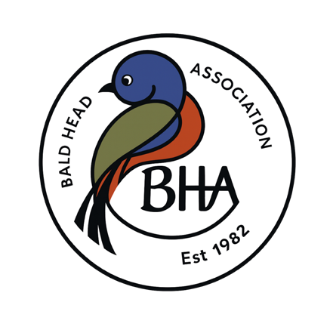

2026 Board Meeting Schedule
All Board Meetings will be held on the 4th Friday of each month and will begin at 8:30 a.m.

Month | Meeting Date & Time
February(Board Retreat) | Friday, February 20, 2026 at 8:30 a.m.  Friday, March 27, 2026 at 8:30 a.m.  Friday, April 24, 2026 at 8:30a.m.  Friday, May 22, 2026 at 8:30 a.m.  Friday, June 26, 2026 at 8:30 a.m.  Friday, July 24, 2026 at 8:30 a.m.  Friday, August 28, 2026 at 8:30a.m.  Friday, September 25, 2026 at 8:30 a.m.  Friday, October 23, 2026 at 8:30 a.m.  Friday, November 20, 2026 at 8:30 a.m.  Friday, December 18, 2026 at 8:30 a.m.
March
April
May
June
July
August
September
October
November
December

